**ONLY SMOKING LEADS TO CANCER???......NO**

**“OBESITY IS ALSO THE NEW SMOKING”**

**OBESITY** is potentially the new **SMOKING**, if we are not careful, said by Dr. MUKUND JOSHI, gastroenterology surgeon at MJM HOSPITAL, PUNE. Obesity could overtake smoking as the chief avoidable cause of cancer related deaths, the world’s largest independent funder of cancer research.

The research published in the British Journal of cancer shows that obesity causes 13 different types of cancer, including bowel, breast, womb and kidney.

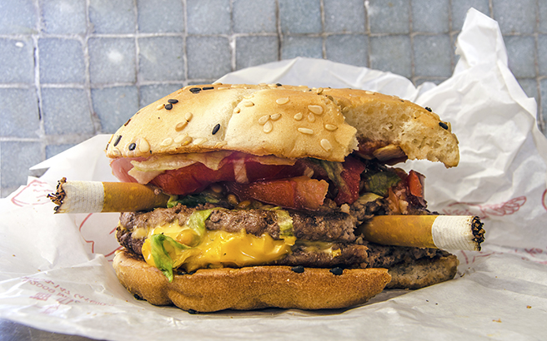 

**MJM HOSPITAL** runs “**OBESITY CLINIC**” in their hospital at Ghole road, Pune. The hospital is instrumental in reducing obesity problems in hundreds of patients.

For more details contact: 09769337236